Quiz 1 - CEE 4674
Airport Planning and Design
Open Book and Notes (75 Minutes)

Your Name __________________________________________________________________

VT Number __________________________________________________________________

Your Signature * ____________________________________________________________

* The answers in this exam are the product of my own work. I certify that I have not received nor I have provided help to others while taking this examination.
Problem 1. (35 points) Show all your work.
The Providence (RI) Airport Authority would like to request your services to study runway length improvements to runway 5/23 at the airport (PVD). The airport authority wants to improve runway 5/23 allowing airlines to conduct takeoffs supporting international services to Europe. Estimate the runway extension needed for runway 5/23 if the critical stage length services have been identified at this airport are shown in Table 1.
In your analysis use the latest version of the Boeing documents for airport design (http://128.173.204.63/courses/cee5614/sites_ce_5614.html#Aircraft_Data). Add 6% to the distance calculated to account for real Air Traffic route conditions and to account for possible weather deviations from the shortest flight path.

Table 1. Critical Aircraft Used in the Potential Re-design of PVD Runway 5/23.
Origin-Destination Airport Pair | Aircraft Flying the Route
PVD - FRA  Providence to Frankfurt (Germany) | Boeing 757-200 with RB211-535E4B engines. Aircraft maximum design takeoff weight is 255,000 lb. Aircraft has a typical two-class configuration.

a) Find the runway length needed to satisfy the proposed route allowing maximum flexibility to the airline. State the airport design temperature, airport elevation and other environmental conditions and assumptions used in your calculations. State the figure(s) used in the aircraft manufacturer documents.

b) Find if the airline could carry two 2,000 kilogram LD-3 containers plus a full load of passengers on the same route. Briefly explain.

Problem # 2 (35 points) Short Answers
a) An airport in the West Coast is considering installing an Engineering Man-made Arresting System (EMAS). The critical aircraft is the Boeing 747-400 aircraft class. Find the length of the EMAS system to stop an overun. State the design speed used in your analysis.

b) The Payload Range diagram shown in Figure 1 applies to a narrow-body commercial aircraft with 150 seats (OEW ~ 84,000 lb.). Find the average fuel used per passenger (in kilograms per passenger) to fly 2,000 nautical miles (already corrected for ATC and weather detour) with a full passenger load plus 3,000 lbs. of extra cargo.

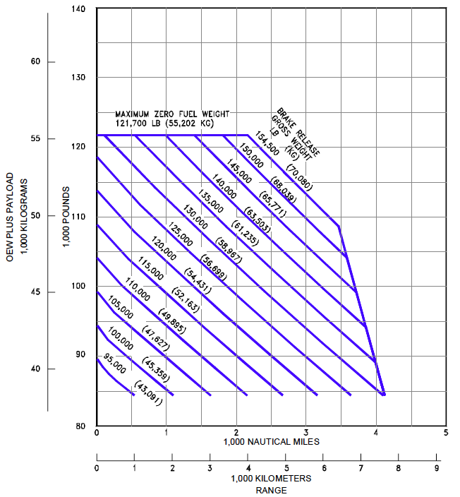
Figure 1. Payload Range Diagram for Part (b) of Problem 2.

Problem #3 (30 points) - Short Answers

a) A new general aviation airport is to be designed and the Gulfstream G550 is used as critical aircraft. State the FAA and ICAO airport design code used for runways and taxiways geometric design standards.

b) In the revision of an existing runway length for a GA airport serving 75% of the fleet of aircraft (using the 60% useful load curves) in the weight range of 12,500-60,000 lbs., an engineer determines 5,350 feet of runway is needed without corrections for wet pavement or runway grade. Suppose the existing runway has a maximum centerline elevation difference of 12 feet. Find the corrected runway length considering wet pavements and grade corrections.

c) Explain what is the impact of high flap settings (i.e., large flap deflections) in the landing distance of an aircraft. Use the Boeing 757-200 (used in Problem 1) performance data to illustrate as needed.

d) Find the suitable runway length needed to accommodate Light Sport Aircraft (LSA) such as the Flight Design CTLS (see the figure below) whose approach speed is 49 knots. The airport is to be built at an elevation of 3,100 feet above mean sea level conditions.
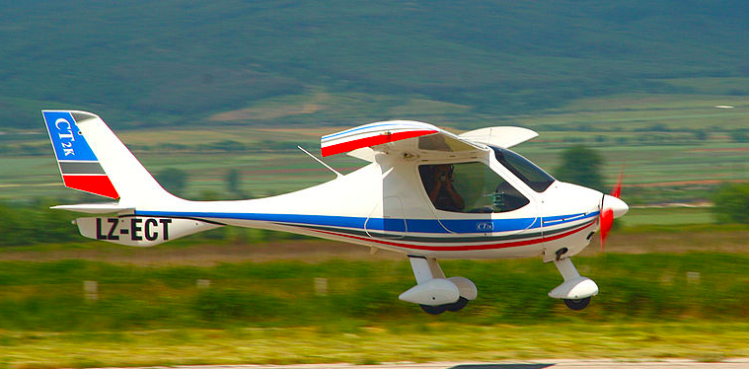
Figure 2. Light Sport Aircraft - Flight Design CTSL (source: Wikipedia).

